Long hair __ |  | Short hair __
Attach hair coat and nails checklist if appropriate
Notes: _______________________________________________________________________________________________________________________________________________________________________________________________________________________________________________________________________________________________________________________________________________________________________________________________________________________________
___________________________________________________________________________________
___________________________________________________________________________________

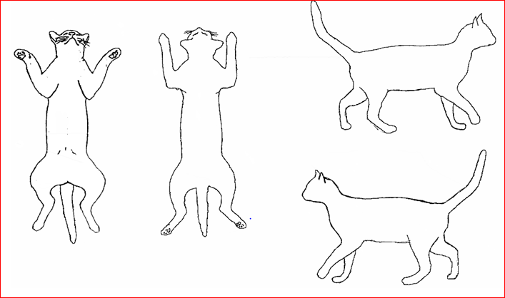

ASPCApro.org

